Assignment-16.3

Task Description #1 – Schema Generation  
Task: Ask AI to design a schema for a Library Management System  
(Tables: Books, Members, Loans)

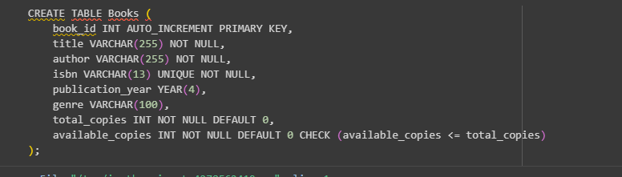

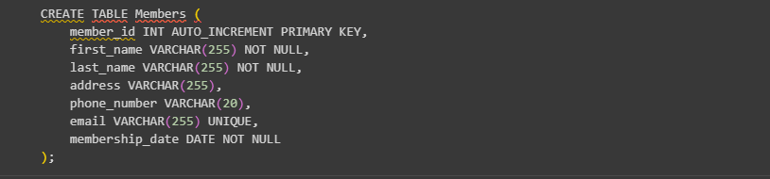

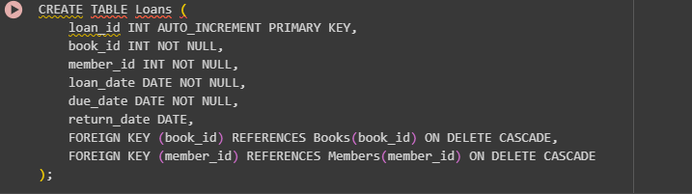

Task Description #2 – Error Insert Data  
Task: Ask AI to generate INSERT INTO queries for the schema above  
(3 sample records per table)



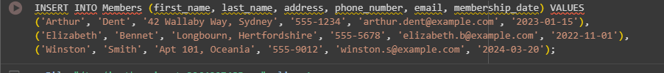

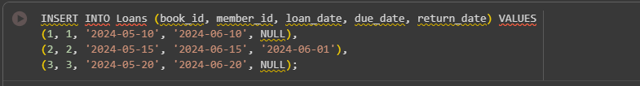

Task Description #3 – Basic Queries  
Task: Use AI to generate a query to list all books borrowed by a specific  
member

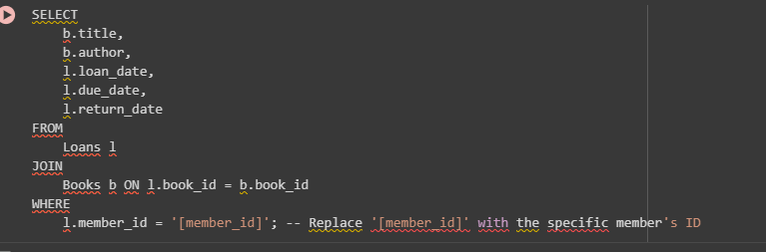

Task Description #4 – Update and Delete Queries  
Task: Generate queries with AI for:  
• Updating a book’s availability to FALSE when borrowed.  
• Deleting a member record safely.

